**Industrial Internship Report on**

**Temperature and Humidity monitoring system**

**Prepared by**

**NAMAN HORA**

|  |
| --- |
| *Executive Summary* |
| This report provides details of the Industrial Internship provided by upskill Campus and The IoT Academy in collaboration with Industrial Partner UniConverge Technologies Pvt Ltd (UCT).  This internship was focused on a project/problem statement provided by UCT. We had to finish the project including the report in 6 weeks’ time.  My project was (Tell about ur Project)  This internship gave me a very good opportunity to get exposure to Industrial problems and design/implement solution for that. It was an overall great experience to have this internship. |

TABLE OF CONTENTS

|  |  |  |
| --- | --- | --- |
| 1 | Preface | 3 |
| 2 | Introduction | 4 |
| 2.1 | About UniConverge Technologies Pvt Ltd | 4 |
| 2.2 | About upskill Campus | 8 |
| 2.3 | Objective | 9 |
| 2.4 | Reference | 9 |
| 2.5 | Glossary | 10 |
| 3 | Problem Statement | 11 |
| 4 | Existing and Proposed solution | 12 |
| 5 | Proposed Design/ Model | 14 |
| 5.1 | Low Level Diagram | 16 |
| 5.2 | Interfaces | 17 |
| 6 | Performance Test | 19 |
| 7 | My learnings | 22 |
| 8 | Future work scope | 23 |

# Preface

Summary of the whole 6 weeks’ work.

About need of relevant Internship in career development.

Brief about Your project/problem statement.

Opportunity given by USC/UCT.

How Program was planned



Your Learnings and overall experience.

Thank to all (with names), who have helped you directly or indirectly.

Your message to your juniors and peers.

# Introduction

## About UniConverge Technologies Pvt Ltd

A company established in 2013 and working in Digital Transformation domain and providing Industrial solutions with prime focus on sustainability and RoI.

For developing its products and solutions it is leveraging various**Cutting Edge Technologies e.g. Internet of Things (IoT), Cyber Security, Cloud computing (AWS, Azure), Machine Learning, Communication Technologies (4G/5G/LoRaWAN), Java Full Stack, Python, Front end**etc.



1. UCT IoT Platform **(****)**

**UCT Insight** is an IOT platform designed for quick deployment of IOT applications on the same time providing valuable “insight” for your process/business. It has been built in Java for backend and ReactJS for Front end. It has support for MySQL and various NoSql Databases.

* It enables device connectivity via industry standard IoT protocols - MQTT, CoAP, HTTP, Modbus TCP, OPC UA
* It supports both cloud and on-premises deployments.

It has features to  
• Build Your own dashboard  
• Analytics and Reporting  
• Alert and Notification  
• Integration with third party application(Power BI, SAP, ERP)  
• Rule Engine

 

1. **Smart Factory Platform (****)**

Factory watch is a platform for smart factory needs.

It provides Users/ Factory

* with a scalable solution for their Production and asset monitoring
* OEE and predictive maintenance solution scaling up to digital twin for your assets.
* to unleased the true potential of the data that their machines are generating and helps to identify the KPIs and also improve them.
* A modular architecture that allows users to choose the service that they what to start and then can scale to more complex solutions as per their demands.

Its unique SaaS model helps users to save time, cost and money.

 

1.  based Solution

UCT is one of the early adopters of LoRAWAN teschnology and providing solution in Agritech, Smart cities, Industrial Monitoring, Smart Street Light, Smart Water/ Gas/ Electricity metering solutions etc.

1. Predictive Maintenance

UCT is providing Industrial Machine health monitoring and Predictive maintenance solution leveraging Embedded system, Industrial IoT and Machine Learning Technologies by finding Remaining useful life time of various Machines used in production process.



## About upskill Campus (USC)

upskill Campus along with The IoT Academy and in association with Uniconverge technologies has facilitated the smooth execution of the complete internship process.

USC is a career development platform that delivers **personalized executive coaching** in a more affordable, scalable and measurable way.



Seeing need of upskilling in self paced manner along-with additional support services e.g. Internship, projects, interaction with Industry experts, Career growth Services

<https://www.upskillcampus.com/>

upSkill Campus aiming to upskill 1 million learners in next 5 year



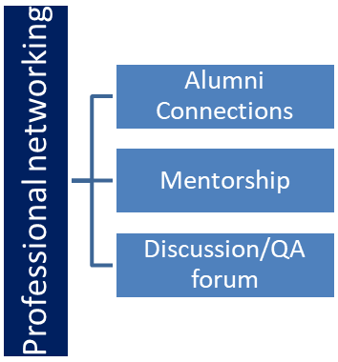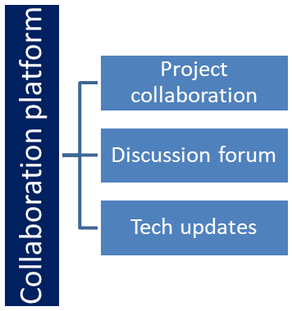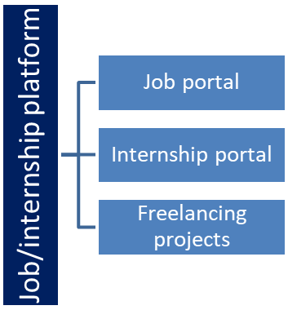

## The IoT Academy

The IoT academy is EdTech Division of UCT that is running long executive certification programs in collaboration with EICT Academy, IITK, IITR and IITG in multiple domains.

## Objectives of this Internship program

The objective for this internship program was to

 ☛ get practical experience of working in the industry.

 ☛ to solve real world problems.

 ☛ to have improved job prospects.

 ☛ to have Improved understanding of our field and its applications.

 ☛ to have Personal growth like better communication and problem solving.

## Reference

[1] Rahman, Rafizah & Hashim, Ummi & Ahmad, Sabrina. (2020). IoT based temperature and humidity monitoring framework. Bulletin of Electrical Engineering and Informatics. 9. 10.11591/eei.v9i1.1557.

[2] IoT Based Humidity and Temperature Monitoring Using Arduino UNO K Hari Kishore, S Pavan Sai Harsha, Sai Sandeep Kumar Allu, P.Surya Teja, E Raghuveera, Fazal Noor Basha

# Problem Statement

The assigned problem statement was Temperature and Humidity monitoring system. The aim was to develop an IoT system for measuring and monitoring the temperature and humidity at any given location. An IoT system consists of a variety of components and requires integration and designing of electronic components, sensors, actuators, software, programming, and a lot more to make it functioning for the required purpose.

Temperature and humidity are very crucial parameters for industries which need to be constantly monitored and play an important role in the quality of the products.

IoT helps to us to remotely measure and monitor these parameters remotely, collect this data, evaluate the conditions and take appropriate decisions, analyze the data and do a lot more.

Temperature and humidity monitoring is a requirement for a number of industries including pharmaceuticals, food and beverages, textile, chemical, air quality monitoring etc.

It helps in monitoring environmental, laboratory conditions, calibration, ventilation, evaluating equipment performance, smooth management, remote decision making etc.

It may be a very basic parameter monitoring system from the look of it but is of great industrial importance.

# Existing and Proposed solution

The existing solution is present for the problem statement with the help of DHT11 sensor and LCD monitor along with Arduino. The temperature and humidity are measured by the DHT11 sensor and passed onto the Arduino which displays it onto the LCD Screen.

The proposed changes I had in mind included use of Bluetooth or wifi to transmit the data wirelessly, to add a warning pop-up incase the temperature or humidity readings go beyond the limit required and to integrate all this in a mobile application to store and analyze monitor the data remotely. I did try to integrate all these ideas but due to time and knowledge constraints I could only complete a few of my objectives.

The Internet of Things (IoT) is the network of objects such as physical things embedded with electronics, software, sensors, and connectivity, enabling data exchange. Wi-Fi is a wireless networking technology that uses various bands of radio waves to transmit information between devices.ESP8266 is a low-cost WiFi microcontroller chip that has the ability to empower IoT and helps the exchange of information among various connected objects. DHT11 sensor is used to measure temperature and humidity of surroundings. It is also generally used to create weather stations.

Working principle of Bluetooth

It is a technology that uses low-power, short-range communication technology that is used for connecting and sharing data between two or more devices electronically. It is used in a wide variety of applications like headphones, phones, etc. The working of Bluetooth consists of sending and receiving signals from one device to another. It sends and receives radio waves by using 79 different frequencies in a band of the spectrum which is centered at 2.45GHz, used for avoiding interference.

Working principle of DHT11

DHT11 is a low-cost digital sensor for sensing temperature and humidity. Humidity is the measure of water vapour present in the air. The level of humidity in air affects various physical, chemical and biological processes. Humidity sensors are of two types based on their measurement units. They are a relative humidity sensor and Absolute humidity sensor. It is a relative humidity sensor. To measure the surrounding air this sensor uses a thermistor and a capacitive humidity sensor.

DHT11 sensor consists of a capacitive humidity sensing element and a thermistor for sensing temperature.  The humidity sensing capacitor has two electrodes with a moisture holding substrate as a dielectric between them. Change in the capacitance value occurs with the change in humidity levels. The IC measure, process this changed resistance values and change them into digital form. For measuring temperature this sensor uses a Negative Temperature coefficient thermistor, which causes a decrease in its resistance value with increase in temperature. To get larger resistance value even for the smallest change in temperature, this sensor is usually made up of semiconductor ceramics or polymers. The temperature range of DHT11 is from 0 to 50 degree Celsius with a 2-degree accuracy. Humidity range of this sensor is from 20 to 80% with 5% accuracy. The sampling rate of this sensor is 1Hz .i.e. it gives one reading for every second.  DHT11 is small in size with operating voltage from 3 to 5 volts. The maximum current used while measuring is 2.5mA. DHT11 sensor has four pins- VCC, GND, Data Pin and a not connected pin. A pull-up resistor of 5k to 10k ohms is provided for communication between sensor and micro-controller.

I executed the system for both Bluetooth and wifi transmission of the data as well as tried to complete the UI for the mobile application but couldn’t link the data with the app yet and will continue to work on it.

## Code submission (Github link)

<https://github.com/naman-hora/IoT-project>

<https://github.com/naman-hora/IoT-project/blob/main/wificode.ino>

<https://github.com/naman-hora/IoT-project/blob/main/bluetoothcode.ino>

## Report submission (Github link) :

<https://github.com/naman-hora/IoT-project>

# Proposed Design/ Model

1. **The proposed solution overview is as follows for IoT system for data logging of DHT11 sensor on a web server using Wi-Fi.**

**Programming NodeMCU ESP8266 for Data logging**

Installing ESP8266 Board in Arduino IDE

The ESP8266 community created an add-on for the Arduino IDE that allows you to program the ESP8266 using the Arduino IDE and its programming language. Before starting this installation procedure, make sure you have the latest version of the Arduino IDE installed in your computer. If you don’t, uninstall it and install it again. Otherwise, it may not work. [https://www.arduino.cc/en/software].

To install the ESP8266 board in your Arduino IDE, follow these next instructions:

Follow below steps in case following two issues occure during installation

1. If after pasting in Additional Board Manger URL in preferences, download is failed
2. No install button appears while in library manager
3. In your Windows PC, open the **File Explorer**, select **View** menu and enable “**Hidden items**“:
4. Go to your **Windows device** (for example C:), open **Users**and find the hidden **AppData** folder:
5. Select the **AppData** folder and open **Local**.
6. Open the **Arduino15** folder, then I recommend deleting all files in this folder.
7. That’s it! Now, you just need to re-install the ESP32 and ESP8266 board add-ons.
8. In your Arduino IDE, go to **File**> **Preferences**
9. Enter **http://arduino.esp8266.com/stable/package_esp8266com_index.json** into the “Additional Boards Manager URLs” field as shown in the figure below. Then, click the “OK” button:

**Note:** if you already have the ESP32 boards URL, you can separate the URLs with a comma as follows:

https://dl.espressif.com/dl/package_esp32_index.json, Open the Boards Manager. Go to **Tools** > **Board** > **Boards Manager…**

1. Search for **ESP8266** and press install button for the “**ESP8266 by ESP8266 Community**“:
2. That’s it. It should be installed after a few seconds.

Install the DHT11 library and the required libraries header file.

Code Logic:

1. Include all the required libraries header file.
2. Set Wi-Fi Network Credentials like: SSID and Password.
3. Define the type of DHT sensor used and the **data pin** where the sensor is connected.
4. Define the handleRoot function which is initiated when the Webpage is opened in the browser using the NodeMCU ESP8266 IP address.
5. Define function, readData() which is used to acquire the data from the DHT11 sensor and send it to the Webpage. In this loop, ESP8266 stores the DHT11 values into two different float variables: temperature & humidity. After that, it converts those float variables into the string and stores their data into another string variable called ‘Data’. Finally, It is sent to the Webpage whenever requested.
6. Inside the void setup() function, initialize the baud rate for serial Monitor. Similarly, Using .begin() function, connect the module with the Wi-Fi using the Wi-Fi SSID and password.
7. Firstly, we call the ‘handleRoot‘ function when a client requests URI (Uniform Resource Identifier) “/”. Secondly, we call the ‘readData‘ function when a POST request is made to URI “/readData“
8. In void loop() function we continuously check for HTTP requests from clients

Write HTML Code for ESP Data Logger Web page.

Compile complete code**.**

**Procedure :**

1. Make connections as per circuit diagram.( connect the DHT11 sensor with NodeMCU and upload the code).Compile source code in Arduino IDE.
2. Connect ESP8266 to desktop and upload source code in NodeMCU.
3. Open Arduino Serial Monitor with 115200 baud rate and get the IP address of NodeMCU.
4. Paste IP address in the web browser. The temperature and humidity readings will be seen on Webpage will look as shown below.
5. After uploading the program in NodeMCU, open serial monitor with 115200 baud rate and get the IP address of NodeMCU. Open it in the web browser, and your Webpage will look as shown below.
6. **The proposed solution overview is as follows** **IoT system for monitoring parameters on smart phone using Bluetooth technology.**
7. Compile source code successfully
8. Upload the code in Arduino
9. Open Serial Monitor and set the baud rate to 9600. You will see the humidity and temperature/ heart beat readings
10. Switch on Bluetooth settings of smart phone and pair HC-05 module and establish connection.
11. Open Arduino Bluetooth Controller Application and click on terminal to view readings of sensors.

## Low Level Diagram (if applicable)

Temperature and Humidity Readings from DHT11 Sensor

NODEMCU ESP8266 Wi Fi microcontroller chip

HC-05 BLUETOOTH Module

Arduino UNO

Temperature and Humidity data on Arduino Bluetooth Controller Mobile Application

Temperature and Humidity data log on Web Server over WiFi

## Interfaces (if applicable)

**Circuit Diagram of ESP8266 Data Logger**

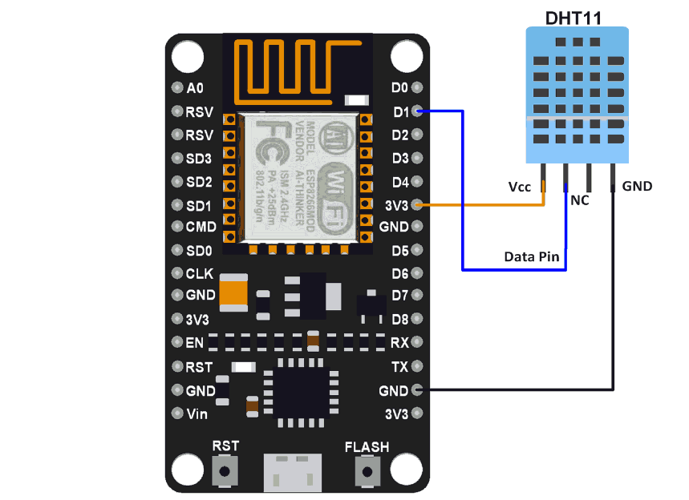

**Components :**

NodeMCU ESP8266

DHT11 Sensor

Jumper Wires

Potentiometer 10k

Breadboard and connecting wires

USB cable.

**Integration diagram For DHT11, HC-05 AND ARDUINO UNO**

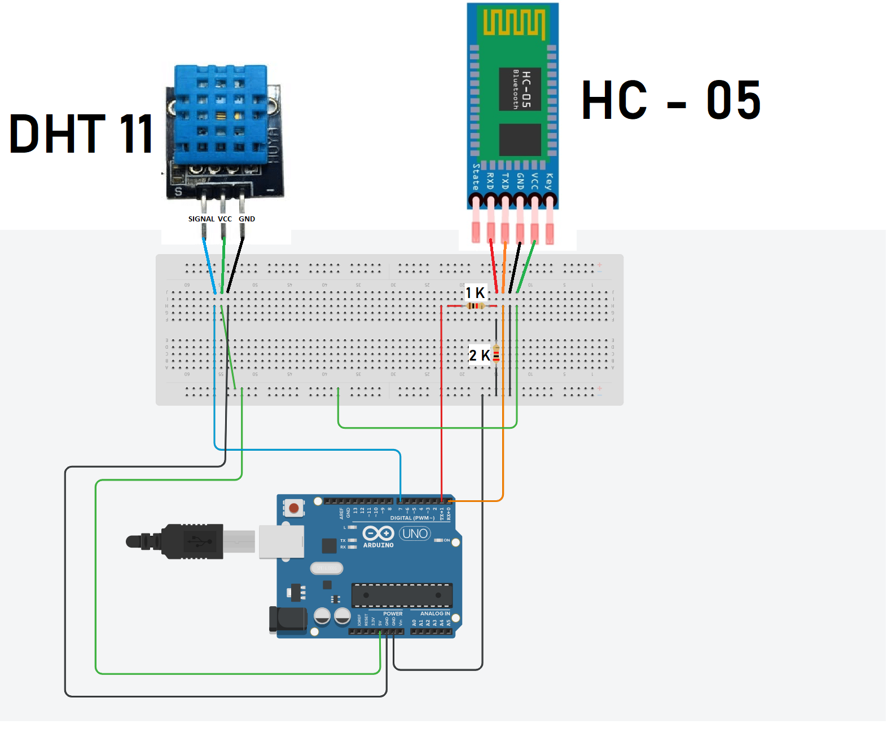

**Components :**

* HC - 05 Bluetooth module
* Pulse Sensor
* DHT11 sensor
* 1 1K Ohms resistor
* 1 2K Ohms resistor
* Breadboard and Connecting wires
* Arduino board
* USB Cable
* Android smartphone and a Arduino bluetooth controller terminal app

# Performance Test

DHT11 SENSOR Operating modes and range:

The DHT11 temperature range is from 0 to 50 degrees Celsius with +-2 degrees accuracy. The humidity range is from 20 to 80% with 5% accuracy. For the sampling rate, the DHT11 is 1Hz or one reading every second, and the DHT11 has a smaller body size. The operating voltage of both sensors is from 3 to 5 volts, while the max current used when measuring is 2.5 mA.

The IoT systems were tested and found performing very well and showing good results using both the wifi module and Bluetooth module.

The code was executed using Arduino IDE and the output was observed on the serial monitor, web browser and the mobile application.

1. **Wifi**

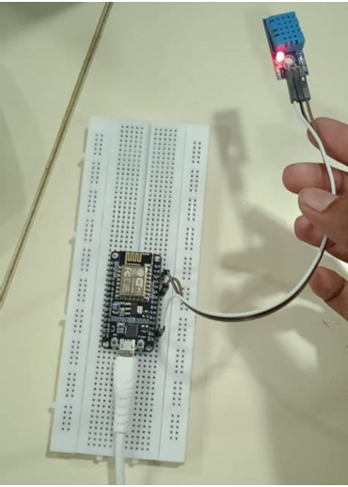

Circuit connected

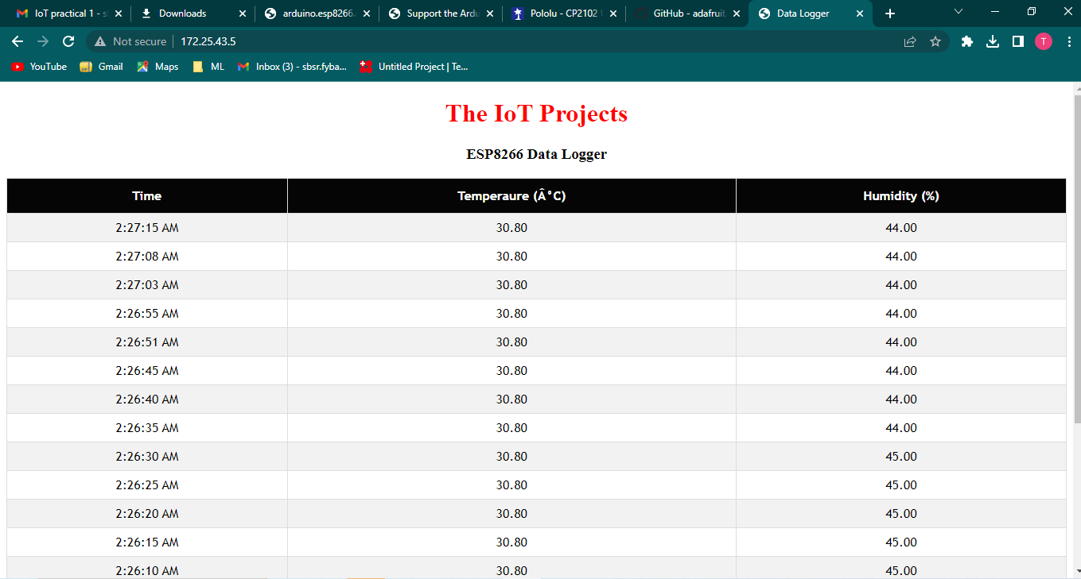

Output on the web server via the wifi module.

1. **Bluetooth**

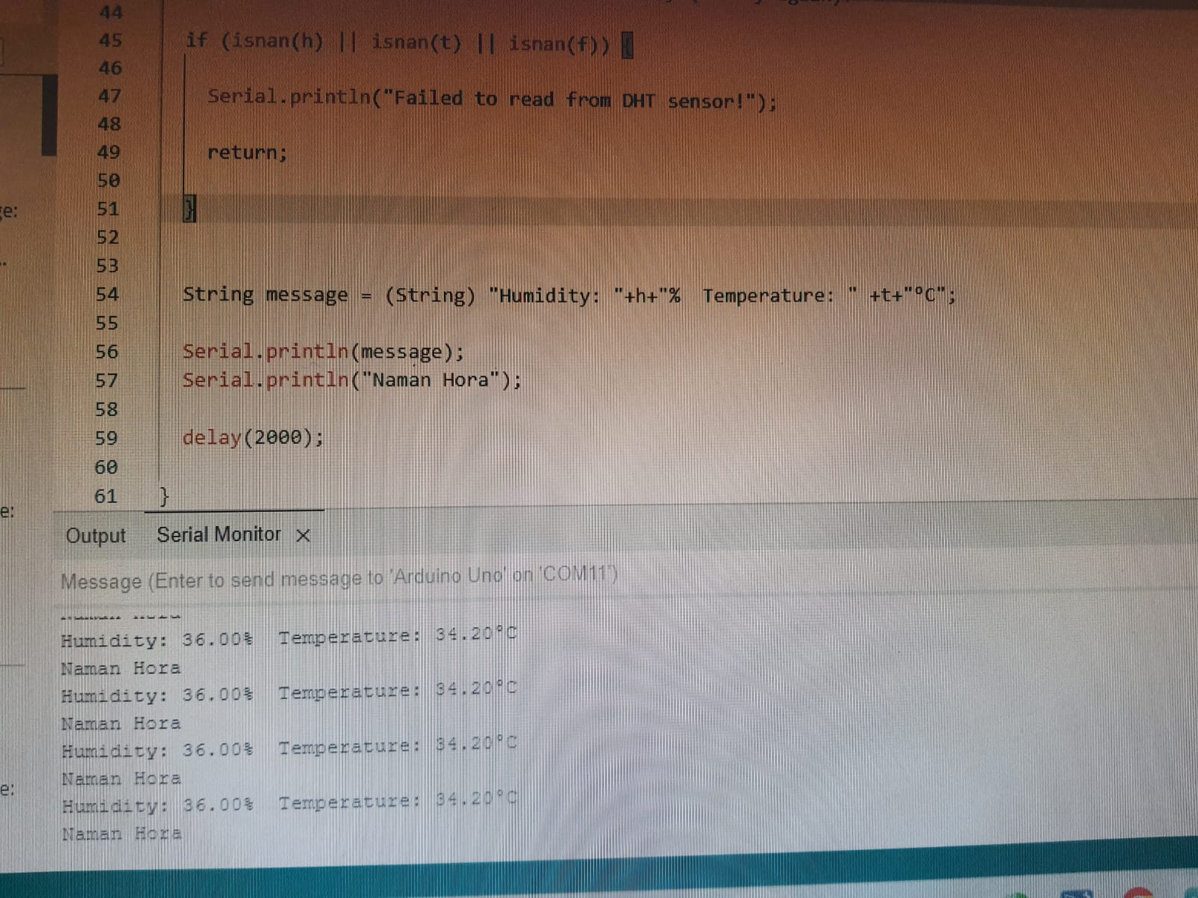

Output on serial monitor of Arduino IDE

x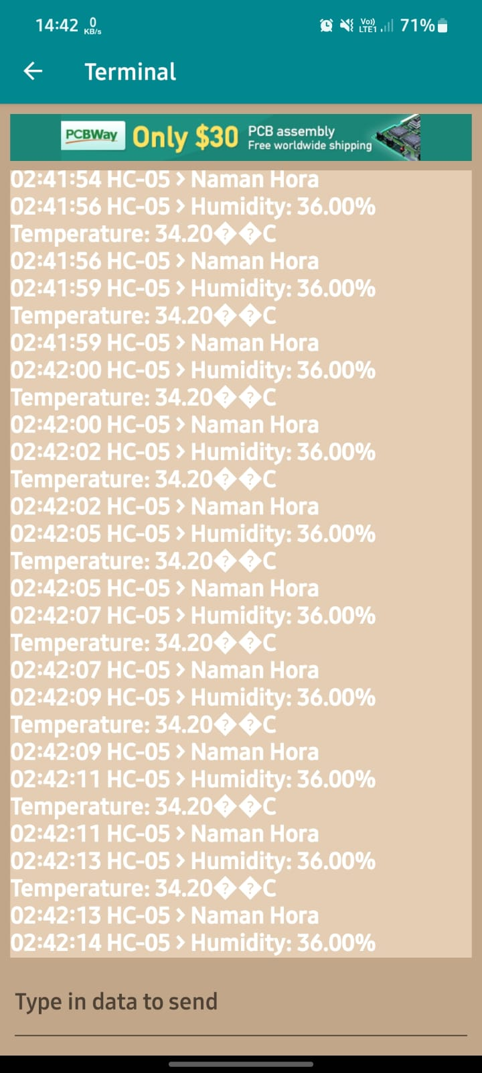

Output on Terminal of the Arduino Bluetooth Controller Mobile Application

# My learnings

The internship and training provided by UpSkill Campus and IoT Academy is a very well designed one. It has helped me to understand about IoT, its importance, its components and layers and its applications in a very systematic manner. In the first two weeks the basics of IoT were very well taught via the resource materials provided. It really made me curious to learn more about it in detail and motivated me to study and research about the topics apart from the course work too. As we know that IoT system is an integration of technologies, it is really a game changing field and one in which you’ll always need to keep learning and stay curious as it always keeps changing and upgrading. The internship, via the coursework and resources helped me to also recall and revise all my basic electronics concepts and helped me to dive deep into the study of embedded systems and IoT.

The real world use cases really helped to get a perspective on the importance of this technology and helped me to gain a better understanding of the industrial applications. The problem statements were well cumulated as all the problem statements were of an intermediate level of difficulty for students and were of great real life industrial application.

The project helped me to learn and practice a whole plethora of skills. I learnt to an IoT system using different electronic components. I learnt how to use the Arduino IDE for coding and uploading the code onto the hardware. I also tried to learn mobile application development using the Android Studio but couldn’t complete it and will continue working on it. In all, it was an opportunity which opened new horizons for me and taught me a lot not only theoretically but also gave me great hands on practical experience and I would really like to thank UpSkill Campus and IoT Academy for providing us with such a great learning platform.

# Future work scope

There is scope for improvement in the project and addition of more features and technologies.These include linking the data from the Arduino to a dedicated mobile app for additional functionalities, creation of an analytical dashboard of the data, and addition of more sensors in the system to monitor more parameters and make an entire ecosystem to monitor, analyze and control these parameters remotely to save time, resources and increase efficiency.